# Global Action on Disability (GLAD) Network Meeting Communiqué[1]

## 3 – 5 February 2020, Washington DC, United States

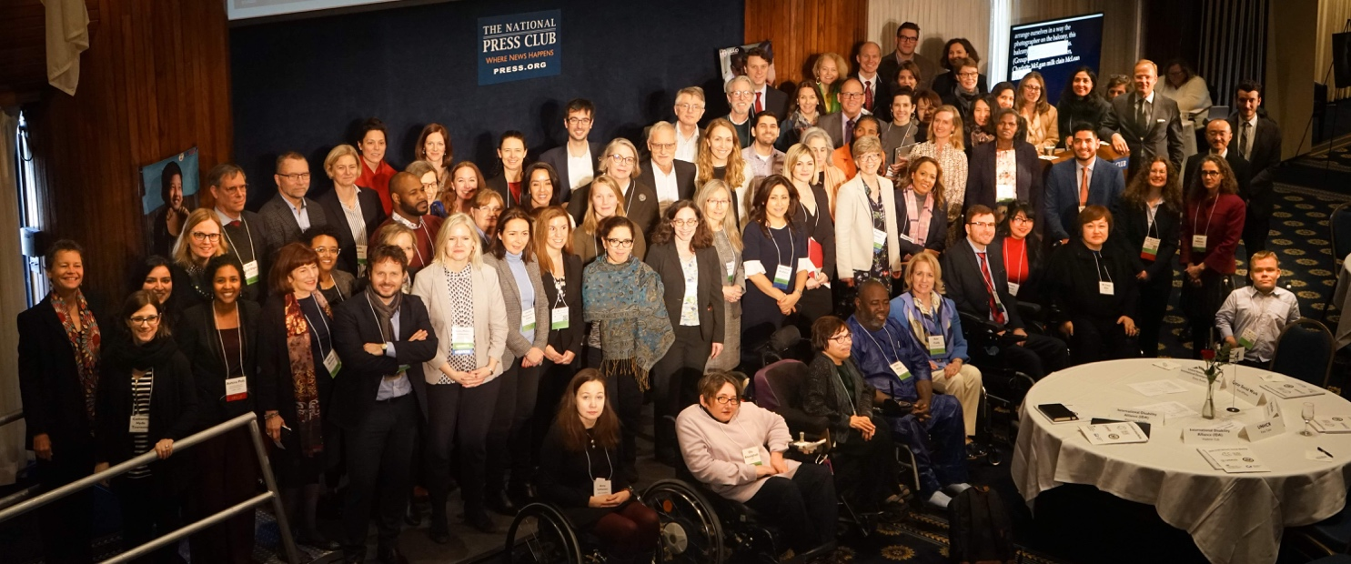

Picture 1: Group picture of participants to the GLAD Network Meeting 2020. Photos in this document are taken by Kristen Dayton @Encompass_world [www.encompassworld.com](http://www.encompassworld.com)

The Global Action on Disability (GLAD) Network met in Washington DC on 3 – 5 February 2020 for its fourth annual meeting. The GLAD Network is a coordination body of donors, including States and their development cooperation agencies, private sector organisations and foundations which aims to enhance the inclusion of persons with disabilities in international development and humanitarian action, consistent with Article 32 of the Convention on the Rights of Persons with Disabilities (CRPD). The United Kingdom’s (UK) Department for International Development (DFID) and the International Disability Alliance (IDA) co-chaired the meeting. The United States Agency for International Development (USAID), together with the United States Department of State, co-hosted the meeting.

The Meeting aimed to further develop Members’ shared commitment to disability inclusive development and humanitarian action while identifying areas for future collaboration and coordination. In particular this meeting aimed to share information on GLAD members’ capacity building initiatives, review and take stock of progress against commitments, and reflect on disability inclusion in relation to climate change, inclusive employment and gender equality. Participants (see attached) agreed key actions on these areas, building on progress since the last GLAD Network meeting in Ottawa from 29 April to 1 May 2019.

The meeting opened with a video message by Mark Green, USAID Administrator, and highlighted that “If countries are to achieve their full potential, persons with disabilities must be able to contribute meaningfully to economic and social growth. They must be included in the leadership their countries need to meet the many challenges that the journey to self-reliance presents”.

Robert Destro, DRL Assistant Secretary,U.S. Department of State welcomed that the GLAD Meeting was held in the United States on the occasion of the 30th anniversary of the Americans with Disabilities Act[2].

The GLAD Co-chairs introduced the main topics of the meeting and welcomed the newest Network Members: The Spanish Agency for International Development Cooperation (AECID), the International and Ibero-American Foundation for Administration and Public Policies (FIIAPP), Fundación ONCE, the Swiss Development and Cooperation Agency (SDC), and the Global Partnership for Education (GPE).

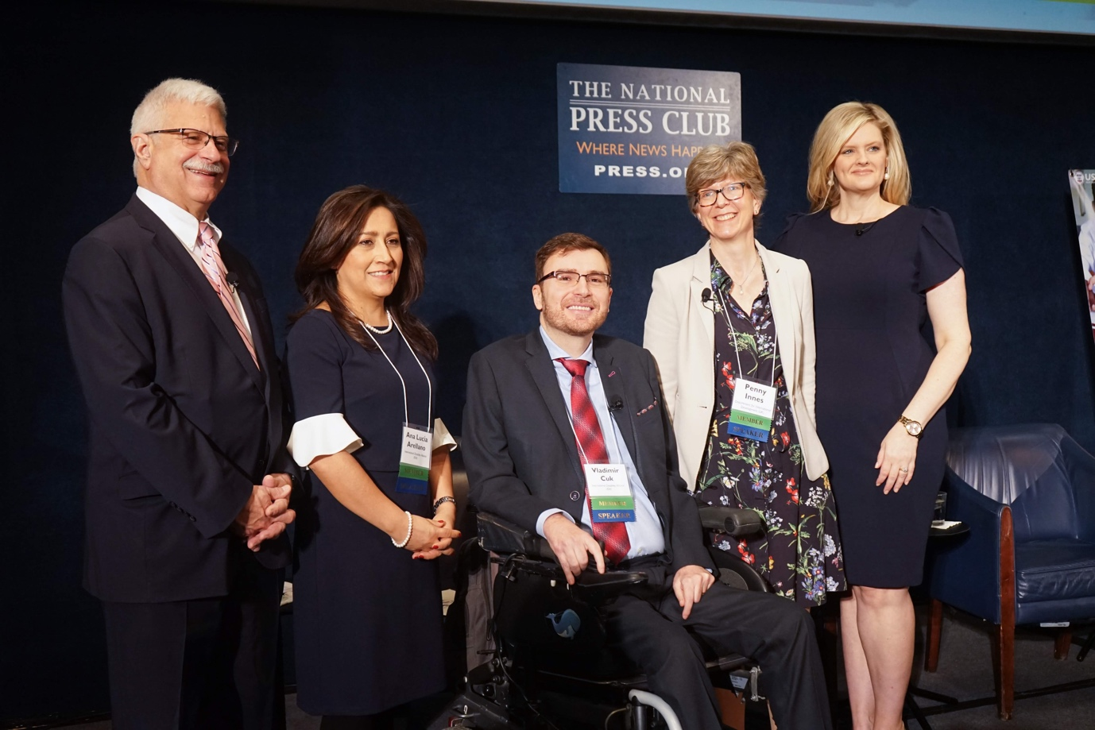

Picture 2: GLAD Network Co-chairs and meeting co-hosts. From right to left side of the picture: Michelle Bekkering, USAID Assistant Administrator; Penny Innes, Head of Disability Team, DFID; Vladimir Cuk, IDA Executive Director; Ana Lucía Arellano, IDA Chair; Robert Destro, DRL Assistant Secretary, U.S. Department of State.

## Process

The GLAD Network is committed to supporting collaboration amongst its members, including by facilitating open dialogue. Accordingly, during the GLAD Network meeting, State agency, multilateral agency, foundation and private sector members held parallel stakeholder discussions to review and take stock of progress and to develop new agreed priorities. Likewise, GLAD members held side events dedicated to thematic working groups focused on GLAD’s priority areas of disability inclusive education, social protection and humanitarian action. Plenary sessions further considered key issues, including those raised in stakeholder and working group discussions. Topics included climate change, inclusive employment, and safeguarding against sexual abuse, exploitation and harassment, in order to develop, as appropriate, a GLAD Network consensus.

## Key Topics

### Global Disability Summit

DFID shared updates regarding progress made in the 18 months since the Global Disability Summit 2018. Nearly a thousand commitments were made at the Summit by more than 170 organizations. The survey conducted by DFID to monitor progress shows that work is underway on 74% of those commitments and completed in 10% of cases. In September 2019 during the UN General Assembly, DFID published the “Global Disability Summit: One Year On – accountability report 2019”[3] setting out more detail on the progress made against commitments, including DPO-led case studies in three countries.

DFID have also worked with partners to design a long-term approach to accountability to keep up momentum on delivery of commitments. GLAD Members welcomed the announcement that DFID will fund a new secretariat from later this year with full‑time members of staff to take forward the accountability work. The secretariat will be housed within IDA and will be responsible for monitoring the commitments, linking with existing mechanisms where possible.

### Organisation for Economic Co-operation and Development (OECD) Development Assistance Committee (DAC) Disability Marker

GLAD Members recognised the unique potential value which the OECD DAC disability marker has for tracking spend on disability inclusive international development and humanitarian action. In June 2018 the DAC Working Party for Development Finance Statistics adopted an OECD DAC policy marker ‘to track development finance in support of persons with disabilities’ and OECD States can now use it on a voluntary basis. The GLAD Network members agreed to continue advocating for the marker to be used by OECD States on a mandatory basis instead of voluntary (as it is currently) as referred in the “Call to Action – Implementation of the Disability Inclusion marker” endorsed by the GLAD Network in May 2019[4].

GLAD Network States members also discussed sharing information on the marker’s use during the stakeholder meeting on day 2 of the GLAD Meeting. It was decided GLAD members would advocate for and support the development of a handbook by the DAC to improve guidance on how to use the marker.

### Recent UN Developments

### United Nations Disability Inclusion Strategy (UNDIS)

This GLAD meeting was held almost nine months from the launch of the UNDIS by the Secretary General in June 2019. The UNDIS Secretariat shared information on the process and advancements of the UNDIS with a focus on its policy and accountability framework, as well as to the accountability framework’s benchmarks and indicators.

GLAD members also welcomed the information that the UN Secretary General has sent a memorandum to the heads of all UN entities to delegate a focal point who will be in charge of coordinating implementation of the UNDIS, as well as developing action plans for implementation of the strategy. So, far 55 UN entities have nominated focal points, and their reporting will allow us to gain a strong baseline on where the whole UN system stands on its work on inclusion of persons with disabilities across programs, operations and coordination.

GLAD Members agreed that there is now a momentum for disability inclusion and that there is a need for a stronger joint advocacy to maintain it. The UN needs to ensure that their policy aspirations are adequately financed, and accountability is maintained at all levels. GLAD members agreed that there is the need to increase financial and technical capacity of the UNDIS and the focal points within the UN system so that they are able to deliver on their commitments.

### Security Council Resolution 2475 and IASC Guidelines

The Security Council Resolution 2475 on situation of persons with disabilities in armed conflict and humanitarian crises was adopted in June 2019[5] and highlights the central role of persons with disabilities and their representative organizations in shaping and contributing to the security agenda, including by attending regular briefings of the security council. The Inter-Agency Standing Committee (IASC) Guidelines on Inclusion of Persons with Disabilities in Humanitarian Action were also adopted in fall 2019. GLAD Members welcomed the adoption of the Resolution and of the IASC Guidelines and agreed to support their implementation. Adoption of both the Resolution and the Guidelines are the result of long joint advocacy efforts by the GLAD Network Members.

## Research on international cooperation of the UN Special Rapporteur on the rights of persons with disabilities

The Special Rapporteur on the Rights of Persons with Disabilities, Catalina Devandas Aguilar, is preparing for presentation at the 75th session of the UN General Assembly (October 2020) a thematic report on disability inclusive international cooperation. The Special Rapporteur will examine six areas (policy development and strategic planning, programming, resource allocation, research, accountability and evaluation, and capacity building) to identify good practice and make recommendations in this space. Consistent with the principle of ‘nothing about us without us’ the research will actively consult with organizations of persons with disabilities and will engage GLAD members and other bilateral donors to get an understanding of good and emerging practices in disability inclusion in international cooperation, including whether current international cooperation efforts are underpinned by a rights‑based approach to disability inclusion. GLAD members, noting GLAD is the embodiment of article 32 of the UN CRPD on inclusive international development cooperation, welcomed this research.

## World Bank IDA19

The final IDA19 replenishment meeting took place in Stockholm, Sweden from December 12 to 13, 2019. A global coalition of development partners agreed on a historic $82 billion financing package for IDA countries for fiscal years 2021-2023, representing a 3%-increase in real terms compared to IDA18. The 19th replenishment will cover the period from July 1, 2020, to June 30, 2023.[6] There is a 3-year window where eligible countries can apply for this funding. This year the IDA19 package explicitly mentions disability as a cross-cutting issue and further presents as an opportunity to provide funding for disability inclusion.

The World Bank noticed that there was a lot of pressure at the Bank to ensure that disability inclusion was part of the IDA19, and this was also thanks to a push from the GLAD Network.

## 

Picture 3: Moderator and Panellists on the podium for the session on upcoming opportunities for the GLAD Network. From right to left of the picture: Mika Kontiainen (DFAT), Miriam Ciscar (AECID), Marc Banzet (Global Affairs Canada), Charlotte McClain-Nhlapo (World Bank).

## Commonwealth Heads of Governments Meeting (CHOGM), Rwanda 2020

The theme of CHOGM 2020 this year captures disability mainly under the subtheme of ‘youth’. In the context of the 2020 plan, GLAD Members were invited to join efforts to make sure inclusion of persons with disabilities comes up as a core issue. In the same line of influencing CHOGM 2020, GLAD Members will seek to closely monitor and find advocacy opportunities through la Francophonie.

## The role of the GLAD Network on capacity building

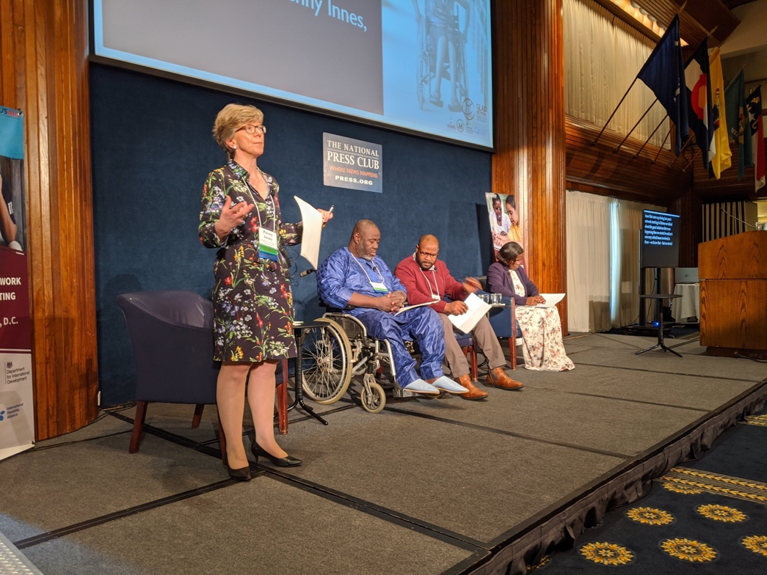Picture 4: Moderator and panellists of the session on capacity building. From left to right side of the picture: Penny Innes (DFID), Idriss Maiga (IDA/ADF) with his interpreter and Gaudence Mushimiyimana (DRF/UNABU).

Following discussions at the GLAD Network meeting in Ottawa 2019, GLAD members acknowledged that DPOs need more support from governments and donors to build their capacity to deliver on new agendas. For this reason, since then and during the 2020 Network meeting, GLAD Members dedicated more time to reflect on how to accelerate and strategize investments in capacity development of DPOs.

GLAD members shared experiences of recent initiatives focused on capacity building, and heard reflections on good practice from two DPOs. There was a strong consensus that there is a need for ongoing focus on supporting capacity building of DPOs and other relevant organisations. GLAD Members agreed to join up their capacity building work better, learning from each other and sharing information. GLAD Members noted that capacity building needs to consider the diversity of organisations at different stages of development and with different aims, and that Members should support DPOs to fulfil a range of roles including leading, implementing, making decisions, advocacy and convening. GLAD Members want DPOs to be long term partners in development and humanitarian action.

GLAD State Members agreed to systematically share information about how they are supporting capacity building and identify opportunities for greater collaboration in capacity building.

DFID is continuing its funding for capacity building of organisations of persons with disabilities (DPOs) to DRF, IDA and UNPRPD, building on the success of its previous Catalyst programme.  The funding to IDA will include a new four-component initiative implemented with Sightsavers: a DPO-led capacity building fund to which DPOs can apply; supporting co-ordination of GLAD Members' investment in DPO capacity development at the national level; developing a technical assistance capacity by DPOs and their allies; as well as setting up a new knowledge management and advocacy portal on disability rights.

## Emerging topics of interest for the GLAD Network

### Climate Change

GLAD Members noted that there is the need to generate more evidence on the impact of climate change on persons with disabilities and that GLAD should work with other marginalised groups including women and girls to demonstrate the effect of climate change on persons with disabilities. DPOs must be recognised as important players within the climate change discourse, and to make this a reality, GLAD Members will need to identify opportunities for joint advocacy.

The Spanish Agency for International Development Cooperation (AECID) presented on the UN Climate Change Conference (COP25) that was held in Madrid 2019, where one of the civil society led side events was on climate change and persons with disabilities. Looking ahead to COP26 to be held in the UK in November 2020, GLAD Network members agreed that ‘leaving no one behind’ cannot be an empty statement when it comes to the discussions around climate change. For this reason, GLAD Members will use their collective advocacy power to influence the upcoming COP26 and other relevant events, in the hope to achieve success in terms of commitments and actions and to amplify the voice of persons with disabilities and find solutions.

### Employment that is inclusive of persons with disabilities

It is well known that when it comes to employment of persons with disabilities we encounter physical and attitudinal barriers. GLAD Members had the opportunity to receive initial information on the barriers that beneficiaries of the DFID, IDA and IDDC Members’ “Inclusion Works Project” are facing in accessing employment and on efforts to build the evidence-base. Within this project, DFID, IDA and IDDC members are targeting the real demand and capacity of employers and the employment market, providing training, accessibility assessments, strengthening and partnering with national business and disability networks. It is critical that inclusive employment initiatives need to focus on both the “demand” side of the labour market and employers and not only on what the employees can offer on the “supply” side.

Inspired by the presentations, GLAD Members agreed that employment efforts need to address the inclusiveness and accessibility of the whole cycle starting from the pre-recruitment and vocational trainings to retention. The Japan International Cooperation Agency updated on their projects on supported employment and GLAD Members noted there is a need to develop a deeper understanding of supported employment. Members agreed that they will share more detailed information on different approaches to inclusive employment across the Network.

### Safeguarding against sexual abuse, exploitation and harassment (SEAH)

During the sessions of the GLAD Meeting, the topic of safeguarding against SEAH came up several times, with Members agreeing that it is everyone’s responsibility to ensure all the people we work with and for are protected from any form of abuse. GLAD Members have zero tolerance of sexual abuse, exploitation and harassment and will put in place appropriate response mechanisms that do no harm. The response mechanism of the donors and funders was particularly discussed with an objective to agree on a process that will not negatively impact organizations and movement of persons with disabilities in any given country. To do that, members will share policies and agree guidance on appropriate responses to safeguarding allegations.

## Stakeholder Mapping

GLAD members reviewed the final report and brochure of the Network’s Stakeholder Mapping Exercise Phase 2 (SME2) that was launched in July 2019 and that builds on the first Stakeholder Mapping Exercise completed in 2016. GLAD Members shared how members made use of it throughout the year and within the working groups. The SME2 proved to continue being an essential tool to facilitate greater cooperation amongst GLAD members by building a shared understanding of the nature, scope, level and likely future direction of their engagement on disability inclusive development.

GLAD Network members shared ideas on future mapping exercises and what they should look like, agreeing that a lighter mapping exercise should be circulated once per year, while a deep mapping (similar to the SME2) should be done every 4 years.

## Thematic Working Groups

### Inclusive Education

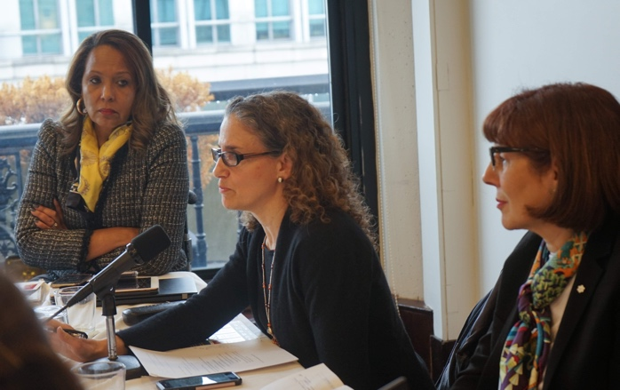 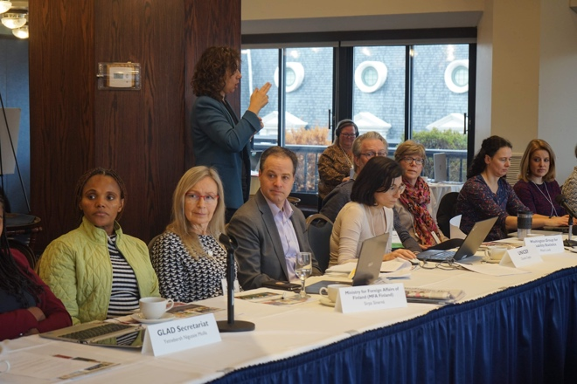

Picture 5: One of the panelists and the GLAD IEWG co-chairs during the inclusive education session. From right to left: Charlotte McClain-Nhlapo (World Bank), Alison Hillman (OSF), Diane Richler (IDA).

The GLAD Inclusive Education Working Group shared updates on the activities undertaken in 2019. Among numerous achievements of this group, it was noted that an inclusive-education-focused mapping exercise[7] that builds on the results of the Stakeholder Mapping Exercise Phase 2 is now available on the GLAD Platform for GLAD Members. This exercise provides information on activities and projects that GLAD Members are doing in Ethiopia, Fiji, Nepal and Rwanda. A sub-group formed by DFID, OSF, USAID, IDDC and the World Bank will work on designing a new mapping exercise to deepen the knowledge of GLAD Members’ and non-GLAD Members’ activities and programmes in Nepal, with the aim of improving cooperation and cohesion at the national level.

The World Bank shared updates regarding the Inclusive Education Initiative and announced that its Community of Practice would be launched shortly after and the IEWG is invited to collaborate.

They also discussed how to maximize dissemination of the IEWG infographic[8]. Julia McGowen of IDDC gave an informative presentation about how the IDDC has disseminated the infographic and trained its members on the concepts therein. The infographic is now available in English, Spanish and French, and members will work to translate the infographic into more languages that will cover more areas of the world. The group agreed to develop a series of events, such as webinars, with the aim of informing colleagues in the field offices on how to use the infographic as a tool toward ensuring that their investments advance the vision of inclusive education elucidated in the infographic.

GLAD Members also welcomed the work of IDA Inclusive Education Task Team Members in the creation of a consensus paper on how to achieve SDG 4 in compliance with CRPD Article 24[9] and agreed to explore way to support its dissemination.

The Education Global Practice of the World Bank was nominated to take over the IEWG co-chair role from the outgoing co-chair, OSF. The Education Global Practice of the World Bank will co-chair the group along with IDA.

### Social Protection

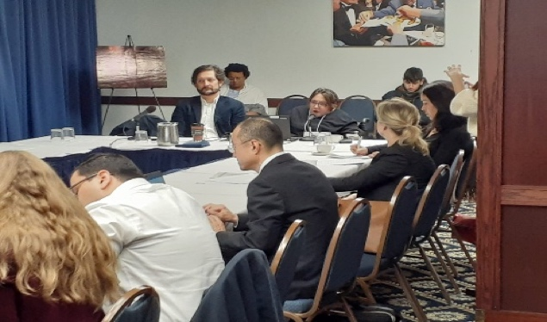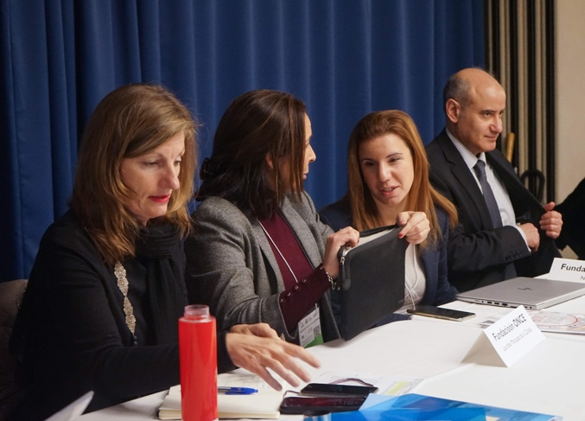

Photo 7 and 8: Participants to the Social Protection session at the GLAD Meeting.

During the discussion around inclusive social protection, members shared information around existing or planned programs. Almost all are engaging in processes supporting development or reform of national social protection systems for greater inclusion of persons with disabilities. The initiatives presented were the UNPRPD funded project led by ILO-UNICEF-IDA, the Joint SDG Fund country programs, and the EU-ILO-UNICEF global program on social protection and public financial management. Support is also provided by other GLAD members such as the World Bank, Asian Development Bank (ADB), United Nations Development Programme, the United Kingdom Department for International Development (DFID), the Department of Foreign Affairs and Trade (DFAT), German Corporation for International Cooperation (GIZ), Japan International Cooperation Agency (JICA) or International and Ibero-American Foundation for Administration and Public Policies (FIIAPP) among others and cover around 1/3 of low-middle income countries. While there is a certain momentum globally, there is still a significant capacity gap to implement reforms that truly foster inclusion and empowerment of persons with disabilities across the life cycle, in line with the 2019 joint statement, endorsed by GLAD and many of its members.

There was a broad agreement that the GLAD network and its members can frame and encourage international cooperation efforts by i) promoting inclusive social protection in platforms such as the Social Protection Inter-Agency Coordination Board (SPIAC B) and Universal Social Protection 2030, ii) contributing to monitoring the level of inclusiveness of investment  in social protection programs, iii) reinforcing the international normative framework, iv) supporting capacity development of national stakeholders and v) coordinating input in CRPD compliant innovative initiatives at the country level.

### Humanitarian action

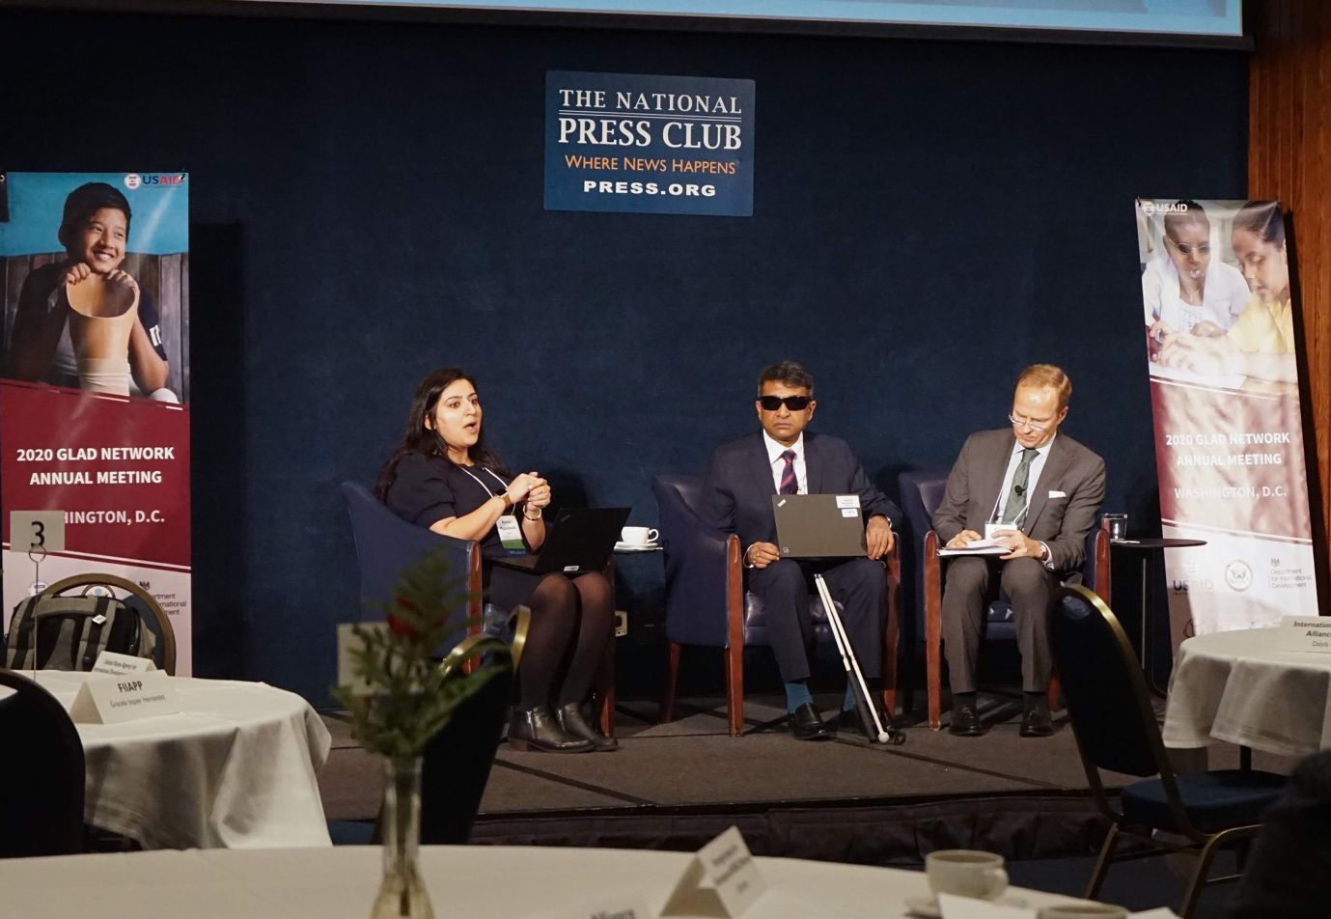

Photo 9: Panellists of the humanitarian action session on the podium. From right to left: Asma Maladwala (UNICEF), Gopal Mitra (UNDIS), Claus Lindroos (MFA Finland).

During the session on inclusive humanitarian action, members had the opportunity to deepen their discussions around three main topics: The Interagency Standing Committee (IASC) Guidelines on inclusion of persons with disabilities in humanitarian action, the Security Council Resolution 2475, and the UN Disability Inclusion Strategy.

GLAD Members identified there were key recommendations coming across repeatedly in relation to the IASC guidelines or the UN disability inclusion strategy. One of the key recommendations that members felt is cross-cutting is leadership. GLAD members will work together to ensure that we have that high-level leadership committed to support the IASC Guidelines and the UNDIS by working through consistent messaging by all Network Members at meetings with their boards, at high-level events and so on.

Another key step that GLAD Members will take is to support capacity of UN Agencies so that they can have tools to fully implement the IASC Guidelines and UN Disability Inclusion Strategy by promoting institutionalized expertise and capacities across all agencies at the HQ as well as down to the regional and at the country levels.

GLAD Members will explore ways to coordinate with the reference group and support the roll out and implementation of the IASC Guidelines and to ensure that there is an emphasis on a more comprehensive coordinated approach so that we are able to move away from the siloed approach.

Regarding the Security Council Resolution 2475 on situation of person with disabilities in armed conflict and humanitarian crises, GLAD Members agreed to advocate to have an open debate on protection of persons with disabilities in armed conflict in the Security Council, to have persons with disabilities and their representative organisations to periodically brief the Security Council on matters related to the Resolution and to start conducting field missions with relevant DPOs.

## GLAD Governance

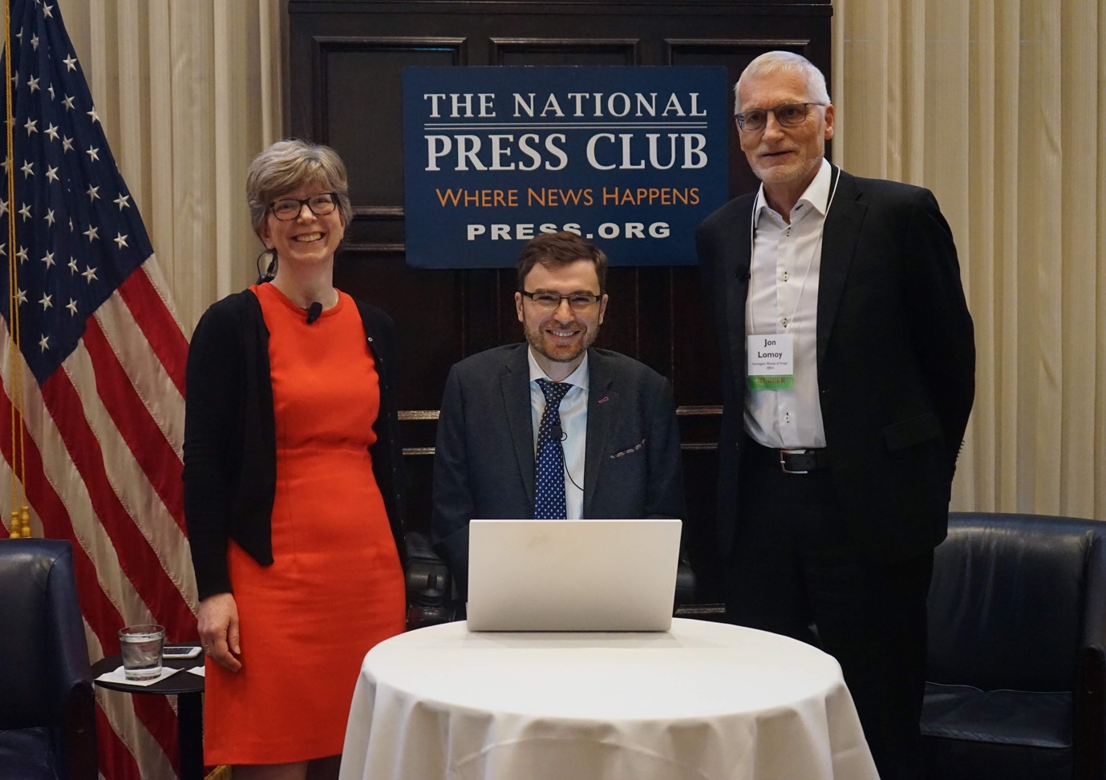

Photo 10: GLAD Co-chairs. From right to left of the picture: Penny Innes (DFID), Vladimir Cuk (IDA) and Jon Lomøy (Ministry of Foreign Affairs of Norway).

The Ministry of Foreign Affairs of Norway expressed the will to join DFID and IDA as a co-chair of the GLAD Network. After the majority of GLAD Members expressed consensus in regards to this proposal, the Ministry of Foreign Affairs of Norway took the role of rotating Co-chair of the Network and Steering Committee in a troika arrangement. DFID will support the in-coming co-chair in the changeover for one year.

The next GLAD Network meeting will be held in the first quarter of 2021. A venue and host for the meeting has not yet been decided.

## Global Action on Disability (GLAD) Network Meeting 3 to 5 February 2020, Washington DC

## Participant list

Jointly organised by the GLAD co-chairs, the UK Department for International Development (DFID) and the International Disability Alliance (IDA) and co-hosted by USAID and the U.S. State Department.

*\*\*Denotes GLAD Steering Committee Member; *Denotes GLAD Network Member; No star denotes Observer or Guest to meeting*

**Abilis Foundation\*\***

Amu Urhonen

Vice chairperson of the Board

Tuomas Tuure

Advocacy Officer

**Disability Rights Fund\*\***

Diana Samarasan

Founding Executive Director

Melanie Kawano-Chiu

Evaluation and Learning Manager

Mushimiyimana Gaudence

Executive Director of Rwandan Organization fo Women with Disabilties/ UNABU

**European Commission**

Maranna Lipponen

Programme Manager

**Ford Foundation**

Judith Diers

Programme Officer

Catherine Townsend

Disability Inclusion Adviser

**Fundación ONCE**

Javier Güemes Pedraza

Director of International Relations

Lourdes Marquez de la Calleja

Technical Director of the Department for Social Relations and Strategic Planning of ONCE Foundation

Natalia Guala

Technical Expert in International Programs

**Global Action on Disability (GLAD) Secretariat**

Federica Settimi

GLAD Secretariat Officer

Yetnebersh Nigussie Molla

GLAD Secretariat Manager

**Global Partnership for Education (GPE)**

Stuart James Cameron

Equity and Inclusion Thematic Lead

**Government of Australia**

**Embassy of Australia**

James Hall

Minister Counsellor, International Development)

***Department of Foreign Affairs and Trade, Australia\*\****

Mika Kontiainen

Director, Disability

**Government of Canada**

***Global Affairs Canada\****

Marc Banzet

Director, Natural Resources and Governance Division

**Government of Finland**

***Ministry for Foreign Affairs of Finland (MFA Finland)\*\****

Claus Lindroos

Director, Humanitarian assistance and policy

Katariina Sario

Senior Adviser, Non-discrimination

Sirpa Sinervä

Senior Advisor on Education

**Government of Korea**

**Korea International Cooperation Agency - KOICA**

Youngran Kim

Attaché for Development

Eunju Jeong

Manager

Mi Yeon Kim

Member, Committee on the Rights of Persons with Disabilities, Adviser of KOICA on Disability

**Government of Germany \*\***

***Bundesministerium für wirtschaftliche Zusammenarbeit und Entwicklung (BMZ)\*\****

Cornelia Henriksson

Senior Adviser

***Deutsche Gesellschaft fur Internationale Zusammenarbeit (GIZ)\*\****

Stefanie Gregorius

Advisor

**Government of Netherlands**

Anna Smulders, Embassy of the Kingdom of the Netherlands

**Government of Norway**

Jon Lomoy

Special representative, Norwegian Ministry of Foreign Affairs

***Norwegian Agency for Development NORAD\*\****

Ivar Evensmo

Senior Adviser

Edle Hamre

Senior Adviser

Morten Eriksen

Director, Atlas Alliance

**Government of Spain**

**Spanish Agency for International Development Cooperation (AECID)**

Miriam Ciscar

Deputy Director of Sectoral Cooperation

**Government of Sweden**

***Swedish International Development Agency SIDA (Sweden)\*\****

Birgitta Weibahr

Senior Policy Specialist, Human Rights and Democracy

**Government of Switzerland**

Simon Sevan Schäfer

Diplomatic Attaché, Embassy of Switzerland to the United States

**Government of the United Kingdom**

***UK Department for International Development\*\****

Penny Innes

Head, Disability Inclusion Team

Rachel Orme

Policy Manager, Disability Inclusion Team

**U.S. Department of State\*\***

Robert A. Destro, Assistant Secretary,

Bureau of Democracy, Human Rights and Labor

Lynn Sicade, Director, Office of Multilateral and Global Affairs, Bureau of Democracy, Human Rights and Labor

Tess McEnery

Section Head for Global Affairs, Office of Multilateral and Global Affairs, Bureau of Democracy, Human Rights and Labor

Ann Cody

Special Advisor, International Disability Rights

Office of Multilateral and Global Affairs, Bureau of Democracy, Human Rights and Labor

Lynne Madnick

Foreign Affairs Officer, Office of Multilateral and Global Affairs, Bureau of Democracy, Human Rights and Labor

Charlie Kellett

Foreign Affairs Officer, Office of Multilateral and Global Affairs, Bureau of Democracy, Human Rights and Labor,

Sofija Korac

Senior Human Rights Adviser, U.S. Mission to the UN

**USAID\*\***

Leah Maxson

Senior Inclusive Education Advisor

Kristen Lentz

Senior Rehabilitation Advisor

Michael Allen

Senior Advisor, Assistive Technologies

Rebecca Levy

Acting Division Chief for the Empowerment & Inclusion Division

Diana Acosta

Deputy Division Chief Empowerment & Inclusion Division

Jessica Benton-Cooney

Lead Communications & Outreach Specialist

Sarah Gesiriech

U.S. Government Special Advisor on Children in Adversity

Sandy Jenkins

Communications Specialist

Tim Meisburger

Director, Center of Excellence on Democracy, Human Rights and Governance

Cathy Savino

Project Director of the Technical Support Contract for the Empowerment and Inclusion Division

Katherine Guernsey

Disability Rights Coordinator

Joshua Josa

Disability Inclusive Education Specialist

Anthony Bloome

Senior Education Advisor

**Judith Heumann LLC**

Judith Heumann

President

**International and Ibero-American Foundation for Administration and Public Policies (FIAPP)**

Graciela Izquier Hernández

Project Officer

Federico Martire

Director, Bridging the Gap

**International Disability Alliance\*\***

Ana Lucía Arellano

IDA Chair

Vladimir Cuk

Executive Director

Alejandro Aguilar

Assistant to Executive Director

Priscille Geiser

Programme Manager

Diane Richler

GLAD Inclusive Education Working Group Co-chair

Yannis Vardakastanis

IDA Bard Member

Idriss Maïga

IDA Board Member

Sue Swenson

IDA Board Member

Jahan Taganova

Logistics assistant

**International Labour Organisation\***

Stefan Tromel

Senior Disability Specialist

**International Disability and Development Consortium (Advisor)\*\***

Dominic Haslam

Chair

Mette Müller Kristensen

IDDC Vice-Chair and DPO

Julia McGeown

IDDC Inclusive Education Working Group

Elizabeth Lockwood

IDDC UN Task Group

Ruby Holmes

IDDC DPO engagement Task Group

**Japan international cooperation agency\*\***

Kenji Kuno

Senior Advisor

Tomomi Saiki

Representative, JICA Washington Office

**International Organisation on Migration - IOM**

Luca Dall’Oglio

Chief of Mission, Washington, D.C.

**Office of the High Commissioner for Human Rights\***

Arnesen Therese

Human Rights Officer, Climate Change and Environment

**Open Society Foundation\*\***

Alison Hillman

Unit Manager

**United Nations Children's Fund**

**UNICEF\***

Asma Maladwala

Consultant, Children with Disabilities Section

Claudia Cappa

Senior Adviser, Statistics

Atif Khurshid

Social Protection Specialist

**United Nations Educational, Scientific and Cultural Organization - UNESCO**

Jennifer Pye

UNESCO IIEP specialist in Inclusive Education

Lily Gray

Liaison and Program Officer

**United Nations Development Programme, UNPRPD Technical Secretariat\*\***

Ola Abualghaib

Manager of the UN Partnership on Persons with Disabilities

**United Nations Disability Inclusion Strategy - UNDIS**

Gopal Mitra

Unit Manager

**United Nations High Commissioner for Refugees – UNHCR**

Jana Mason

Senior Advisor, External Relations & Government Affairs

Katie Tobin

External Relations Officer

**Washington Group for Disability Statistics and National Center for Health Statistics\***

Jennifer Madams

Associate Director for Science, NCHS

Julie Weeks

Lead Statistician

Mitch Loeb

Health Scientist

**Wellspring Advisors\*\***

Myroslava Tataryn

Program Officer, Disability Rights

**World Bank\*\***

Charlotte McClain-Nhlapo

Global Disability Advisor

Social Global Practice

Hanna Katriina Alasuutari

Global Thematic Lead for Inclusive Education, Education Specialist, Education Global Practice

Anna-Maria Eftimiadis

Senior Partnerships Specialist

Social Global Practice

Ruchi Kulbir Singh

Consultant

Social Global Practice

**World Food Programme - WFP**

Kirsten Young

Senior Protection Advisor

**Personal Assistants**

Ramatou Mounkala Souley

Issoufi Maiga Alzouma

Omar Almoctar Guero

Mohammed Abualghaib

Kalyan Debnath

Dalyla Perez

Evangelia Kalimani

Soyul Park

Stevie Mays

Anan Ochun

**Support staff**

Stewart Hickman, Meeting Facilitator

Ashira Pelt, USAID GROW Events

Jennifer Collins-Foley, USAID GROW Events

Kristen Dayton, USAID GROW Events

Lauren Godfrey, USAID GROW Events

**Note-takers**

Natalie Petrulla

Zene Mesfin

Emma Venetis

Debra Howe

Ben Schwertner

Mutsa Makufa

1. Issued by the co-chairs in consultation with the participants.
2. <https://adata.org/learn-about-ada>
3. <https://www.gov.uk/government/publications/global-disability-summit-one-year-on-accountability-report-2019>
4. <https://gladnetwork.net/search/blog/call-action-implementation-disability-inclusion-marker>
5. <https://www.un.org/press/en/2019/sc13851.doc.htm>
6. <http://ida.worldbank.org/replenishments/ida19-replenishment>
7. <https://gladnetwork.net/search/resources/glad-iewg-members-activities-nepal-rwanda-ethiopia-and-fiji>
8. <https://gladnetwork.net/search/resources/glad-infographic-inclusive-education>
9. <http://www.internationaldisabilityalliance.org/resources/inclusive-education-ida-consensus-paper-how-achieve-sdg-4-compliance-crpd-article-24>